**Cover Page**

**CSCI 2272 - Computer Organization and Lab**

**Lab Report 8**

**Student 1 Name and BC Email: Grace Wagner - wagnerge@bc.edu**

**Student 2 Name and BC Email: Jonathan Nushi - nushi@bc.edu**

## Circuit 1

## Design

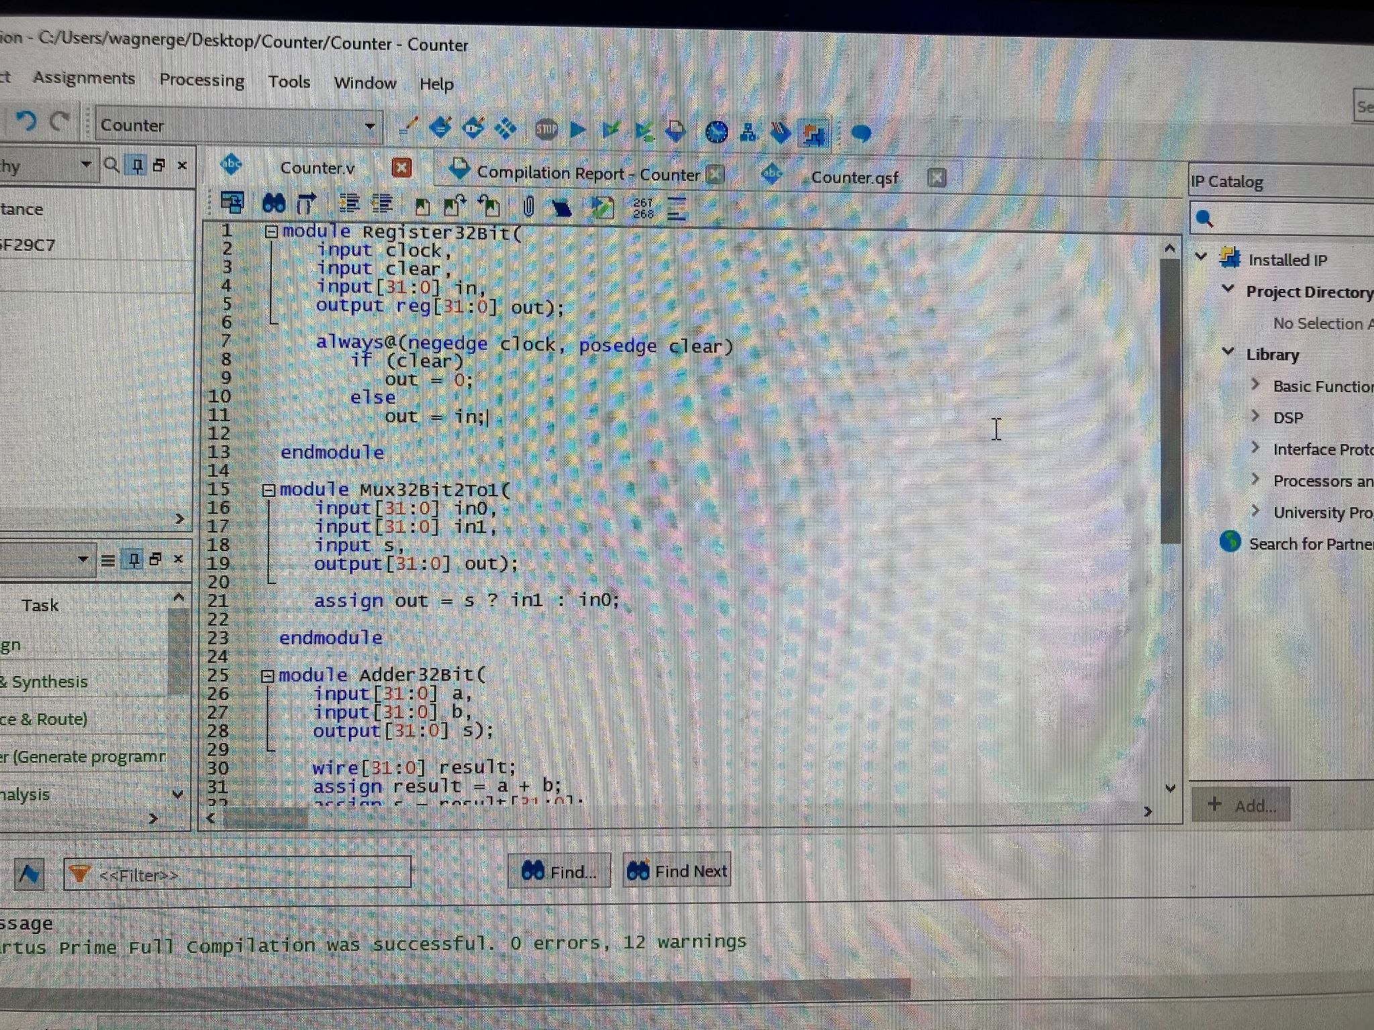

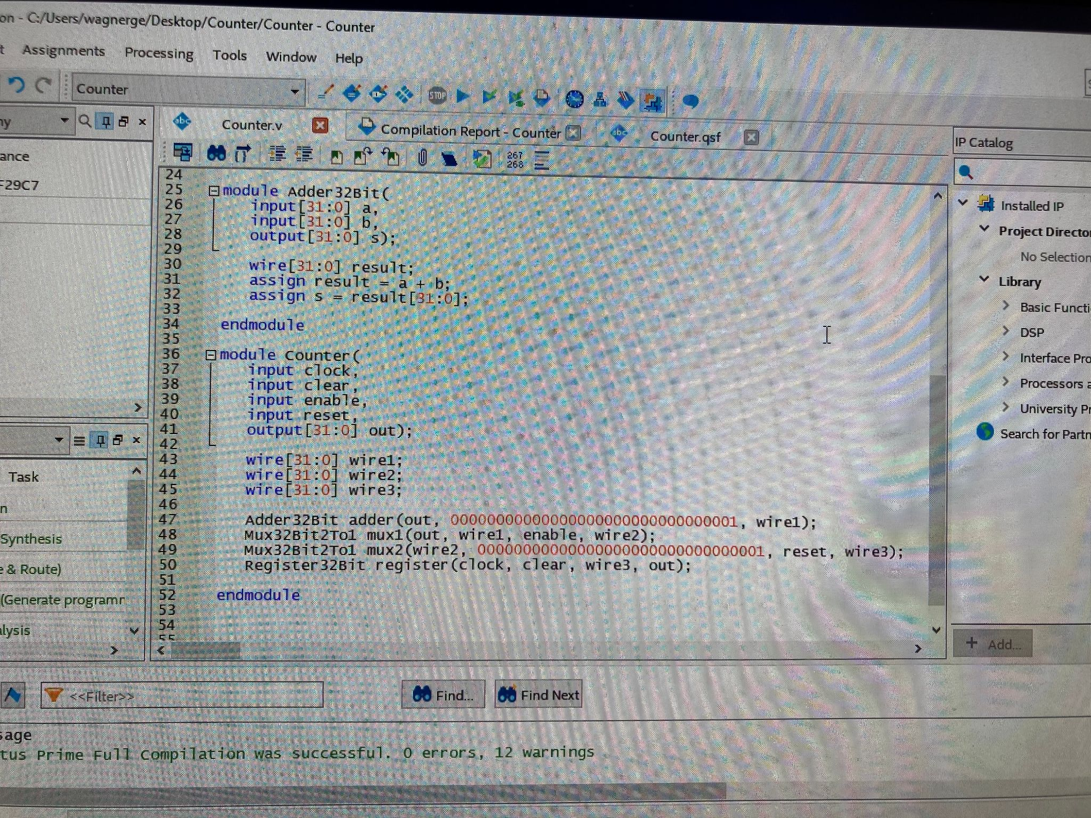

## Output

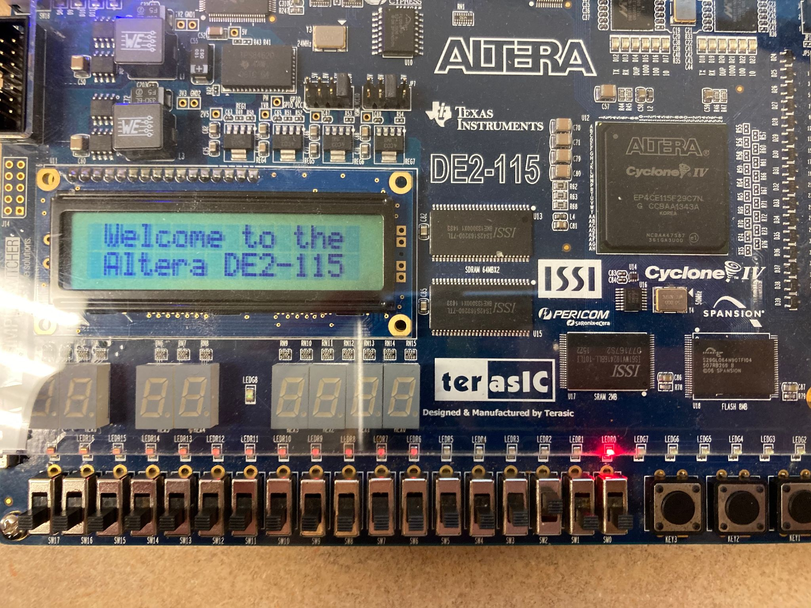

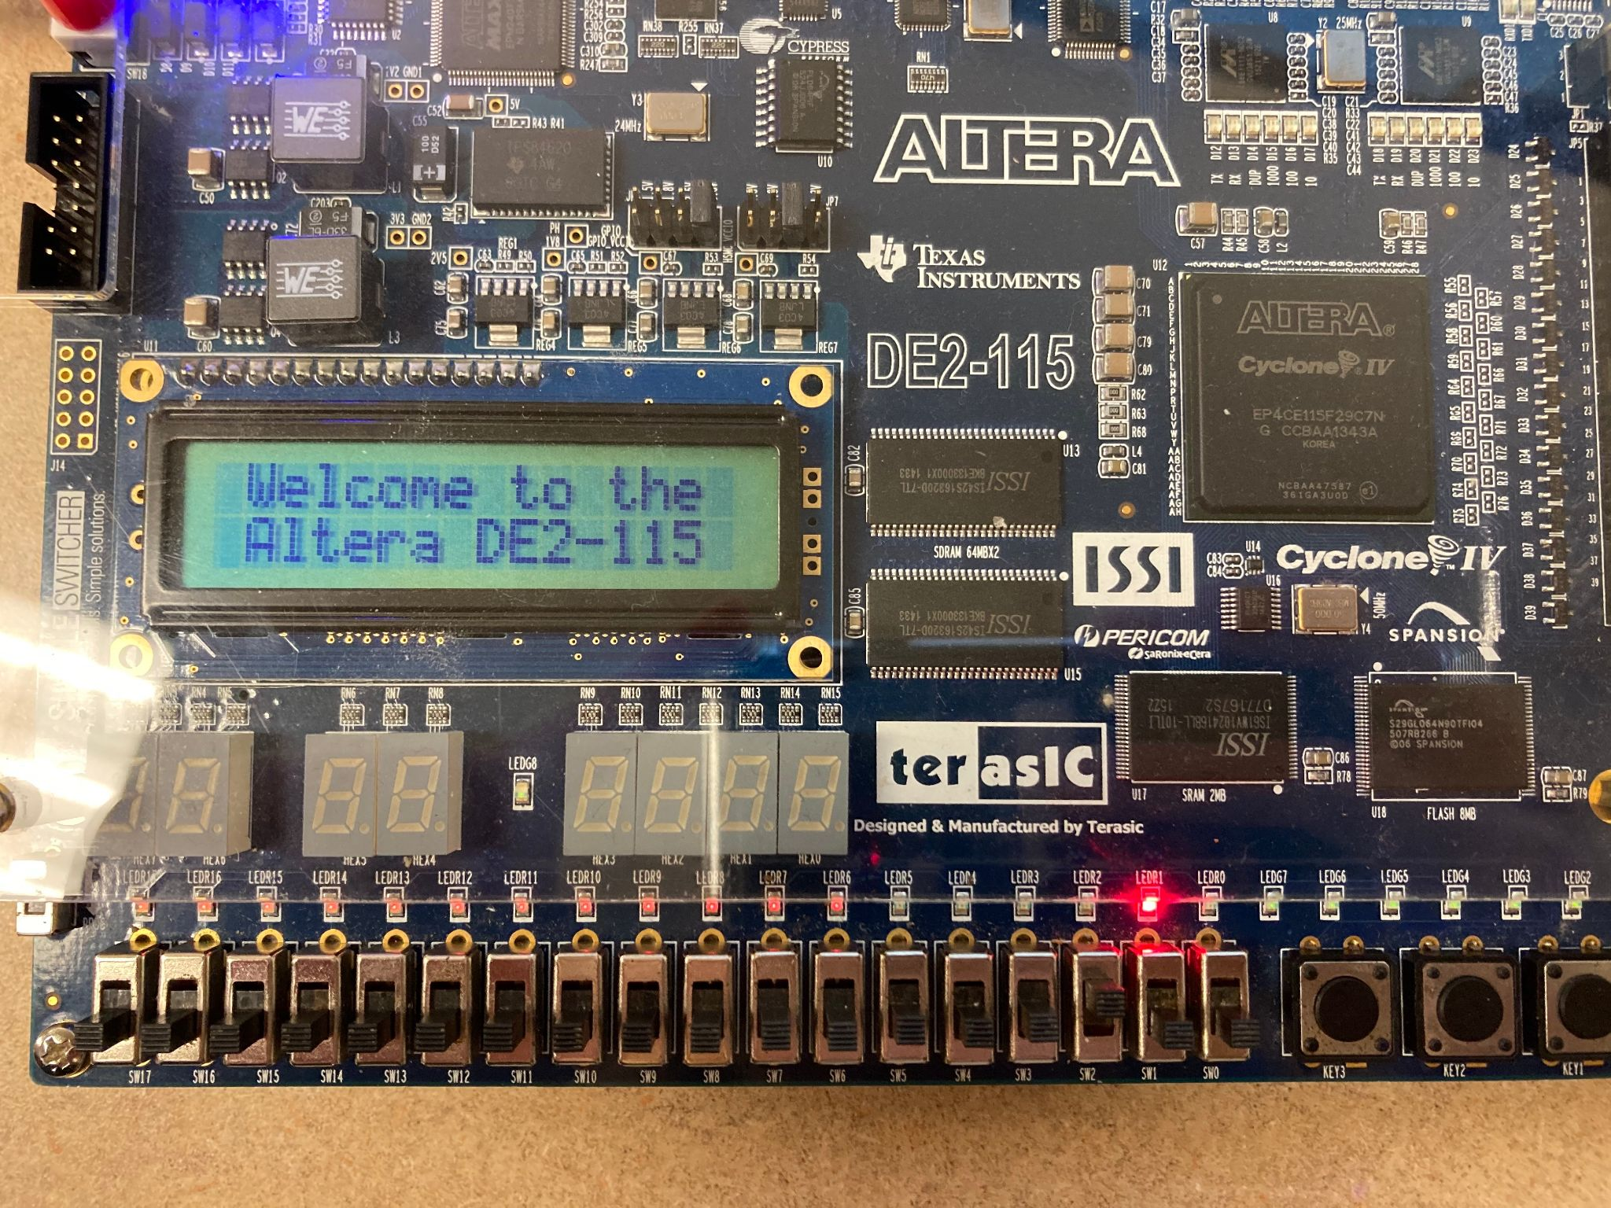

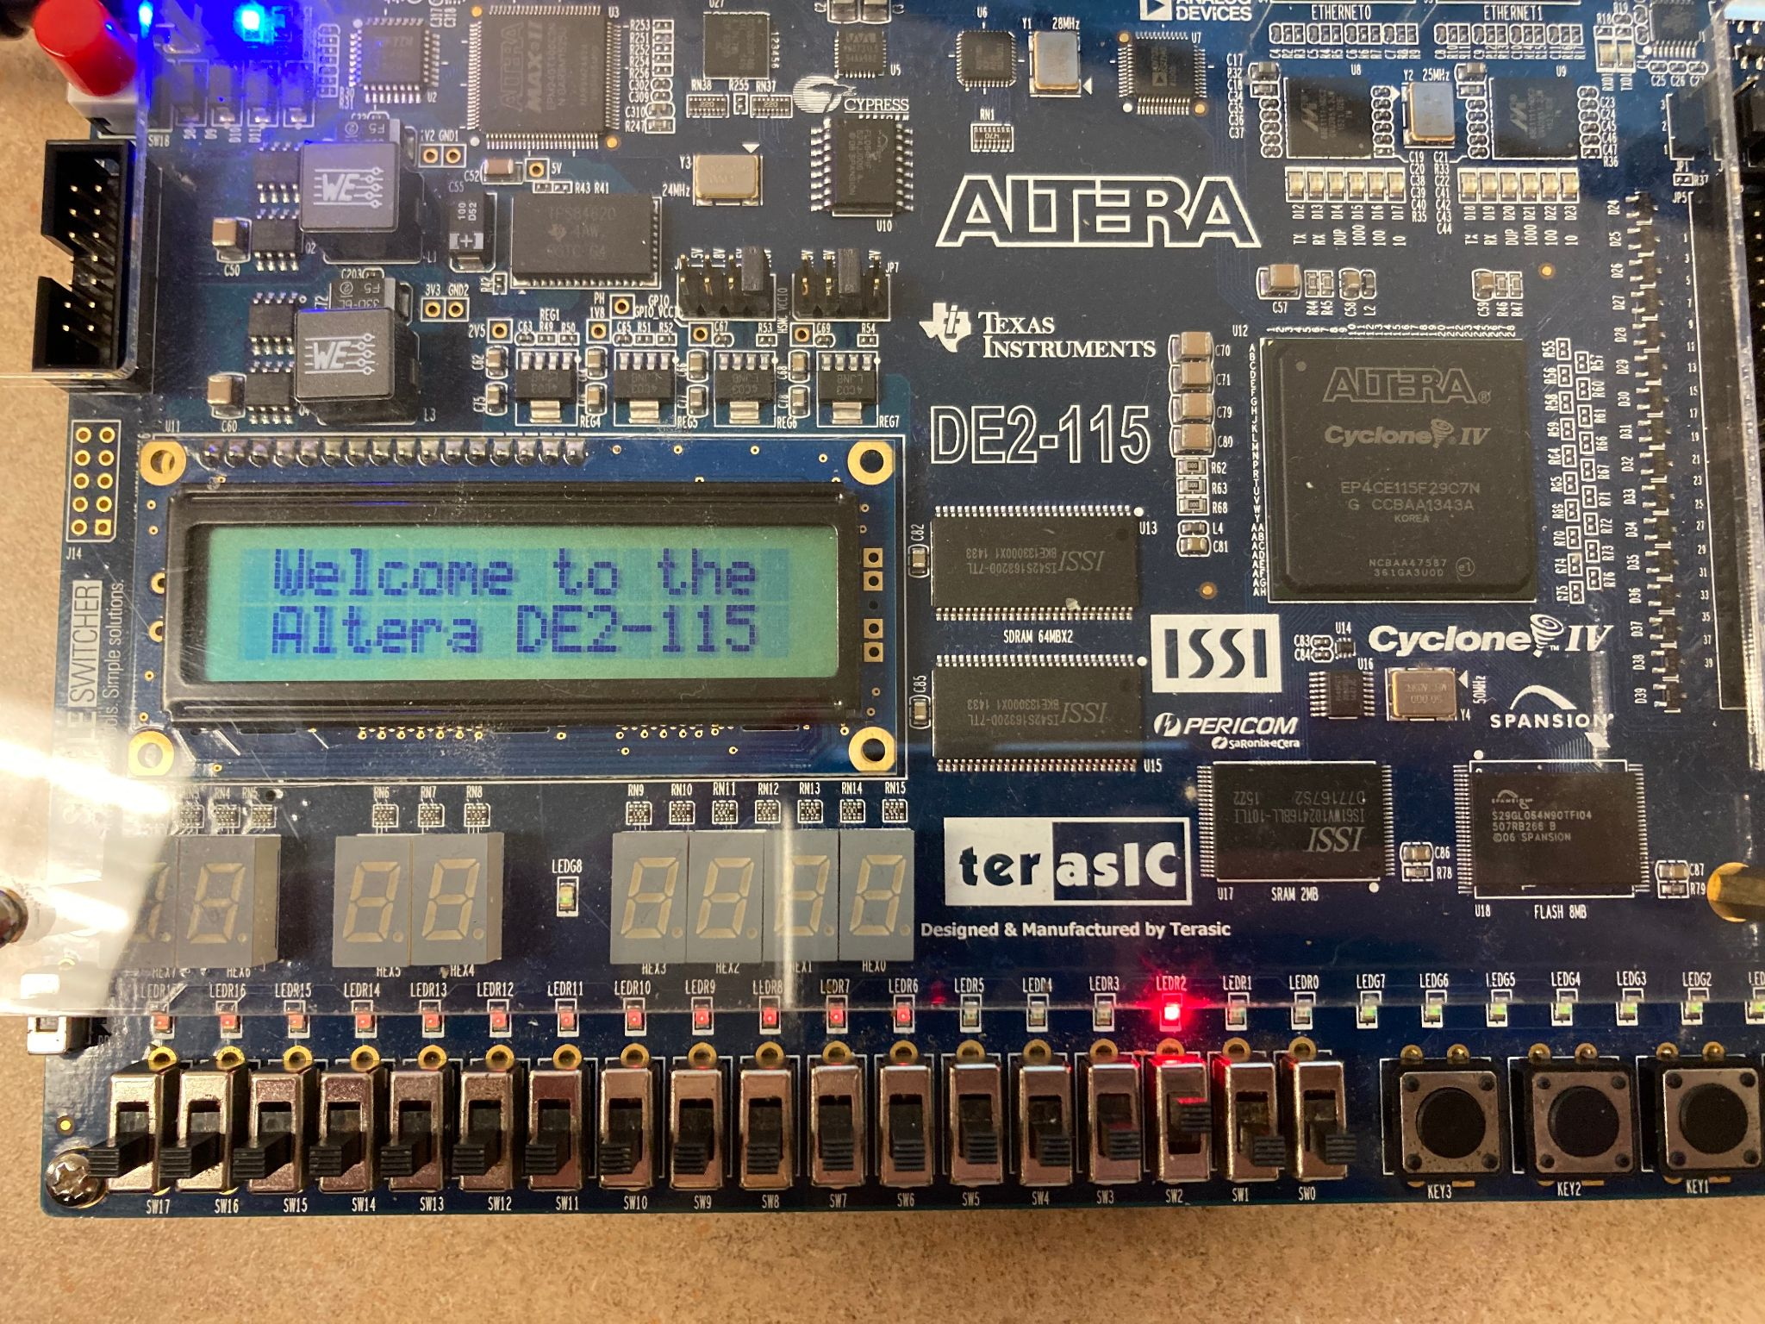

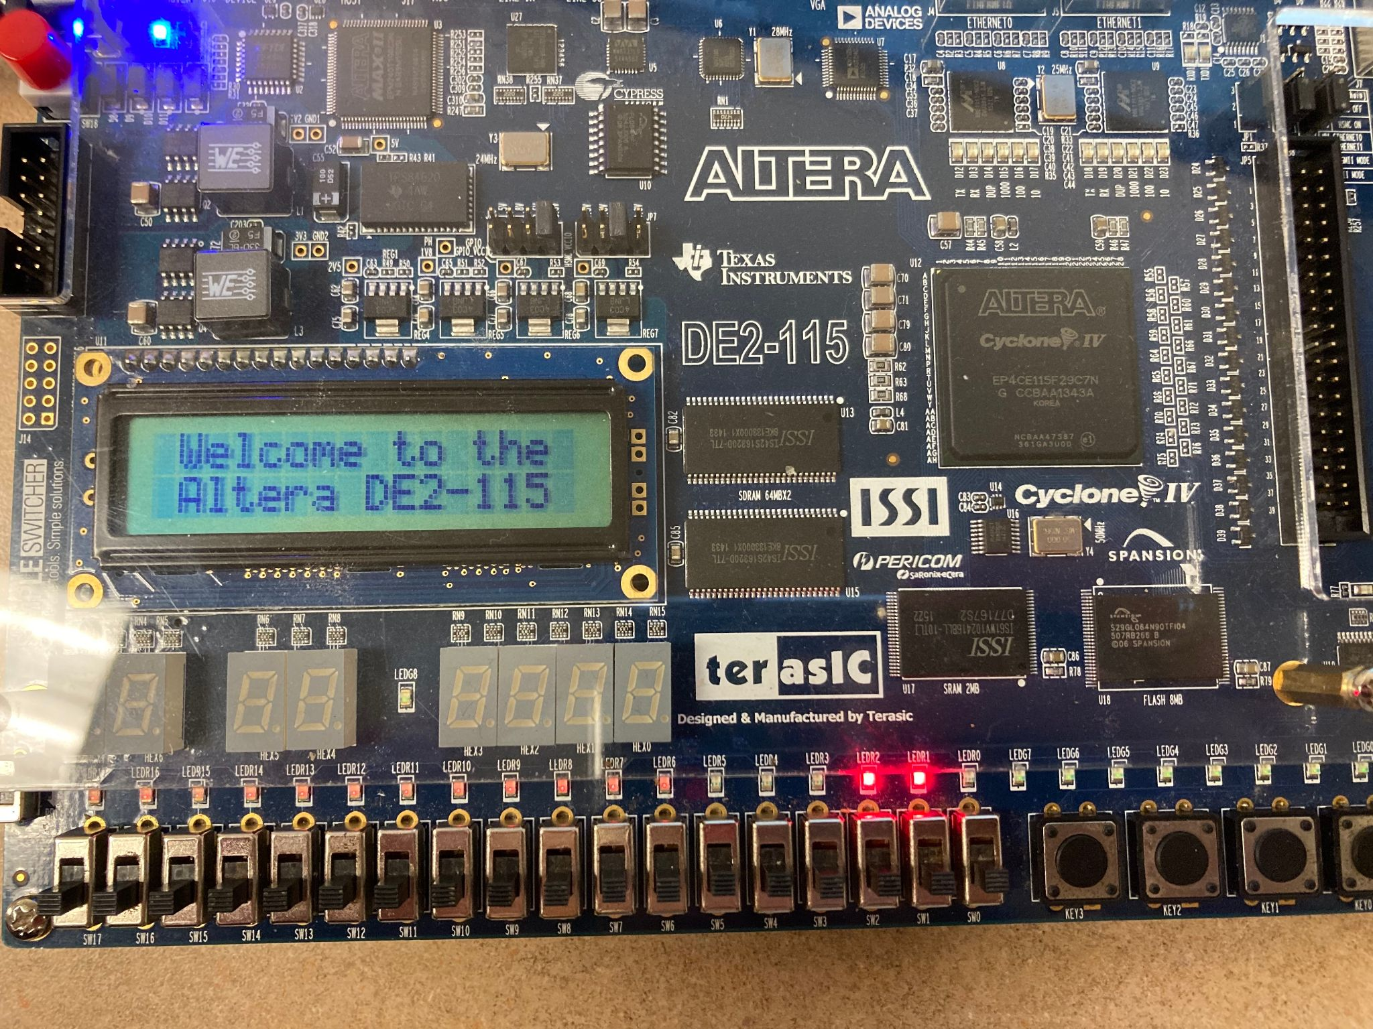

## 

## Reflections

1. What did you learn from this lab?

In this lab we learned how to program a counter on the altera board that automatically adds to a total on a specific time interval, as well as operations to stop and reset the counter.

1. What errors did you face and explain how you resolved them? Feel free to collect screenshots of errors or copy and paste them here?

We had some trouble getting the red LED lights to display on the Altera board at first, we originally tried checking a simulation of our waveform to correct this issue but it turned out to be related to syntax errors in our code.

1. What tasks did each of you perform in the lab? You can say we both did everything together or if you divided tasks amongst yourself or some other way that you used to accomplish this lab?

Grace - Implemented the modules from previous labs and made any adjustments necessary, wrote the Counter module, operated the Altera board.

Jonathan - Reviewed the Verilog code, checked that the pin assignments were correct.

1. What reference material did you use for this lab? If it was a resource from the web, please include it here.

We used the lab guide and pin assignments provided, as well as some related code from previous labs.